**MAKERERE UNIVERSITY BUSINESS SCHOOL**

**FINAL EXAMINATION FOR THE BACHELOR OF BUSINESS COMPUTING   
OF MAKERERE UNIVERSITY, ACADEMIC YEAR 2016/2017**

**COURSE NAME:** PROGRAMMING IN ORACLE

**YEAR OF STUDY:** II

**COURSE CODE:** BUC2221 **DATE:** 11TH – 05 – 2017

**SEMESTER:** II **TIME:** 2:00 – 5:00 PM

**INSTRUCTIONS:**

1. Attempt all questions/statements in Section A using the HR account (**username:** **hr** and **password:** **hr**). You will have to create your own account to attempt questions in Section B. The instructions for creating your account are provided in the same section.
2. Write all answers in your answer booklet.
3. Use appropriate aliases for columns wherever you have used expressions and or functions.
4. All questions in SECTION A carry equal marks as indicated.

**SECTION A: (@ 4 Marks up to a 60 Marks Total)**

1. Show all details of all employees.
2. Show all details of all employees whose first_names end with characters 'rn'.
3. List only those employees who earn a commission percentage. This list should include the column showing commission percentage for each employee.
4. The Human Resources Manager (HRM) has asked for the list of all employees showing their names and salaries.
5. The HRM plans to increase employee salaries in the next financial year by 18.5%. List all employees with their current salary and new salary (18.5% increment), to be included in the plan.
6. Edit the query produced in statement 5 above to apply to only those employees whose salary is less than 2,000 USD.
7. A list of all employees who belong to a department whose identity number is 40 ordered by the last name column in ascending order.
8. Count the number of employees in each department. The result should be ordered by the department identity number.
9. Limit the results returned in statement 8 above to show only those departments that have more than 10 employees.
10. What is the total salary spent on all employees in the organization?
11. What is the total salary spent on each department in the organization?
12. In an upcoming 2016 annual staff party, employees who have spent ten or more years in the organization are to be recognized and rewarded for their loyalty and long service. List all employees that qualify for this reward.
13. CEMAS can automatically create accounts for all staff if you give it a list of staff with their first and last names, valid email addresses and phone numbers. While creating this list, use the existing email column to generate valid lowercase email addresses (with “@mubs.ac.ug” extension).
14. Who earns the highest salary in the organization?
15. All employees are to be given transport allowance for an upcoming general assembly at the company head quarters. To calculate this allowance, the finance administrator has requested for a list showing all employee names and the city that each employee works in.

**SECTION B**

You must follow the instructions below before attempting this section.

**Instructions**

1. Disconnect from the HR account if you are already connected. To do this, type DISCONNECT and press Enter on your keyboard.
2. Connect to the SYSTEM administrator account. To do this, run the code below:

CONNECT SYSTEM / hr

1. Create an account for yourself. Use your last name as your username and your first_name as the password. Use the code below as a guide to create your account:

CREATE USER type_your_last_name_here  
IDENTIFIED BY type_your_first_name_here  
DEFAULT TABLESPACE users  
TEMPORARY TABLESPACE temp  
QUOTA 500M ON users  
PROFILE default  
ACCOUNT UNLOCK;

After successfully creating your account, run the code below:

GRANT CONNECT, RESOURCE TO type_your_last_name_here;

1. Now disconnect from the SYSTEM account and connect to your new account. Use your account and the tables below to attempt this section.

**ERD for Course Facilitator Evaluation System**

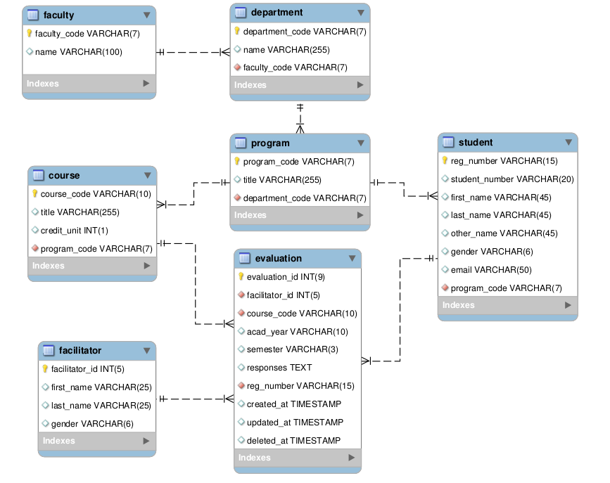

***Additional Notes:***

Use the NUMBER datatype for all columns with INT datatype and VARCHAR2 datatype for all columns with the VARCHAR in the ERD above. The values in the brackets remain the same.

1. Create the tables above, enforcing all necessary constraints (primary keys, foreign keys, checked columns, not null columns and unique keys) in the same CREATE statement. *(16 Marks)*
2. Rename all tables to their plural form for example from faculty to faculties.   
   *(10 Marks)*
3. Insert at least three appropriate records into each of any two of the above tables. *(10 Marks)*
4. Drop any two constrains, one of which must be from a table you have already inserted data into. *(4 Marks)*